**What is Excessive Internet Use?**



**Character and Citizenship Department**

**Learning Series – Cyber Wellness**

**Excessive Internet Use**



As part of character and citizenship education, the Learning Series Booklet – Cyber Wellness aims to raise parents’ awareness on Cyber Wellness education in schools and encourage active parenting to reinforce Cyber Wellness at home.

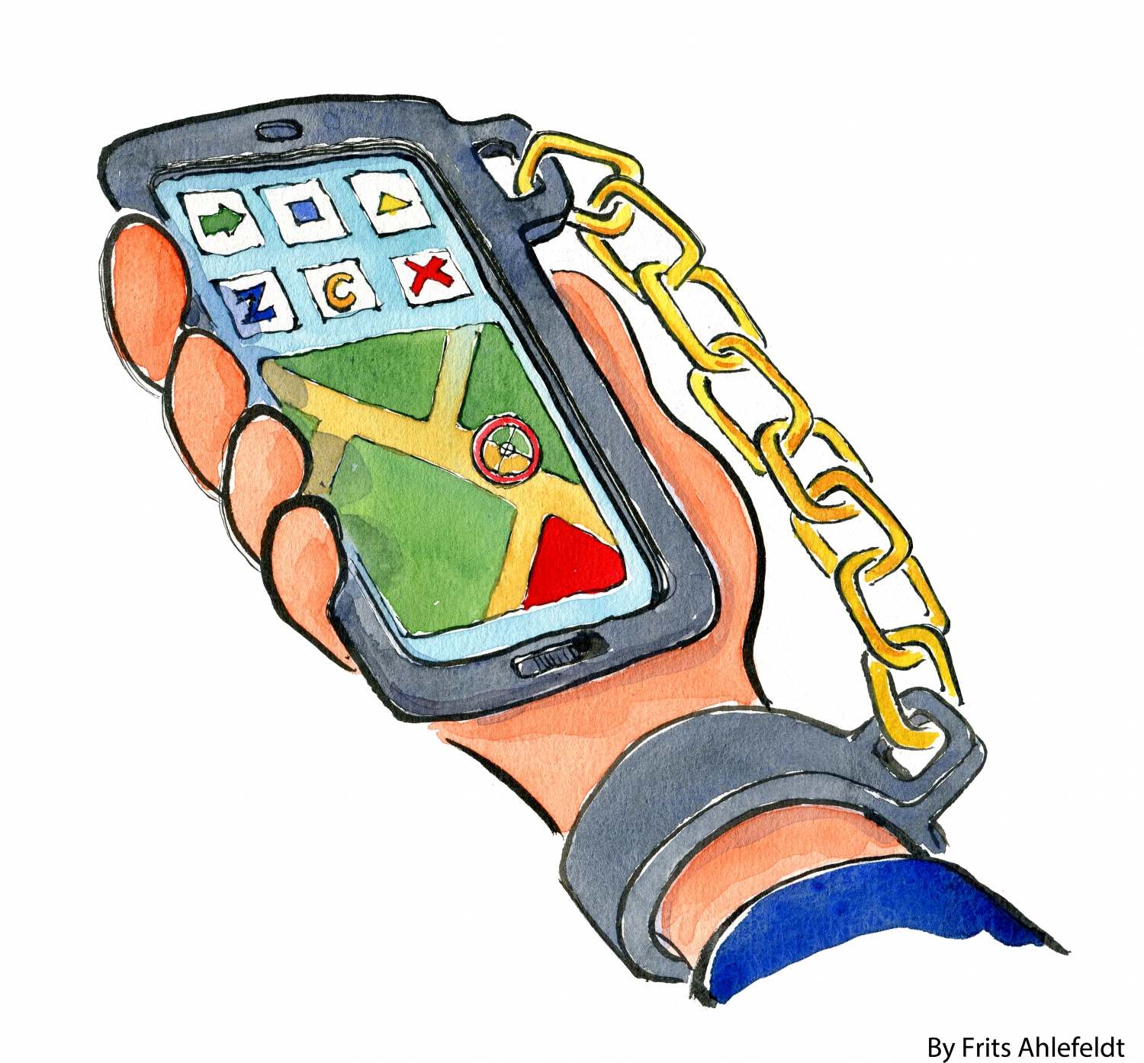

Excessive Internet Use happens when an individual who uses the Internet to the extent where he/she experiences problematic outcomes that negatively affect his/her life.

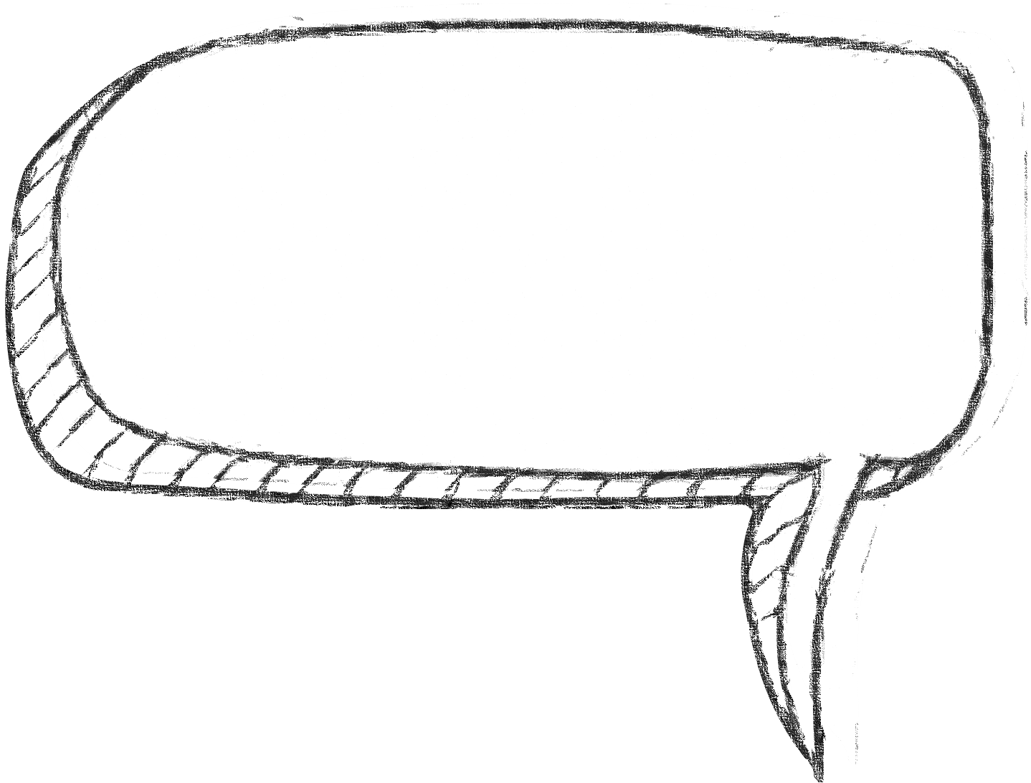

* Needs to spend an increasing amount of time using the Internet before

achieving satisfaction

* Becomes irritable or violent when disrupted from the use of digital devices
* Academic performance and health are affected
* Tries to go online less often but is unsuccessful
* Prefers digital device / Internet use to social events or offline activities that may lead to strained relationships with family and friends
* Constantly listens out for the phone when away from it, feels distressed when it cannot be found

**What are the signs of Excessive Internet Use?**







**What can parents do to help their children manage their use of digital devices?**



**Set screen time limits, tech-free family times (e.g. meal times) and zones (e.g. bedrooms)**

**Organise tech-free family activities and promote tech-free hobbies.**

**Promote and role model balanced Internet use.**

**Talk about the consequences of Excessive Internet Use with your child.**

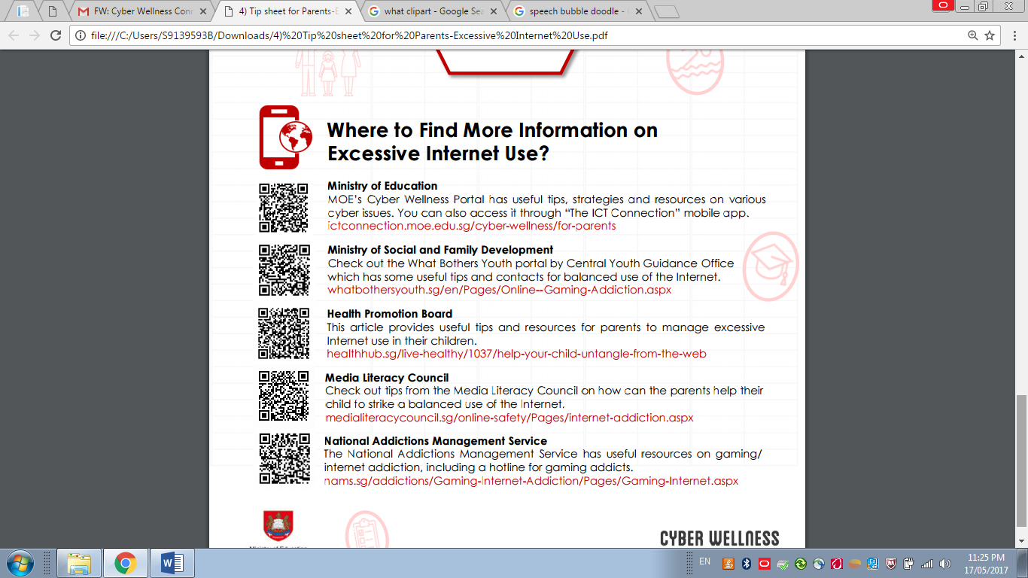



**Cyber Chongfu**

**http://cyberchongfu.weebly.com/**

