What is Cyber Bullying?
Character and Citizenship Department
Learning Series – Cyber Wellness
(Parent’s Edition)
Cyber Bullying
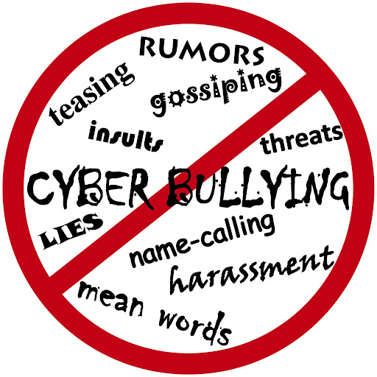

As part of character and citizenship education, the Learning Series Booklet – Cyber Wellness aims to raise parents’ awareness on Cyber Wellness education in schools and encourage active parenting to reinforce Cyber Wellness at home.
Cyber bullying occurs when electronic gadgets, such as mobile phones and computers; social media; and Internet services are used as a means to intentionally hurt someone in cyberspace. With cyber bullying, negative content can be shared, saved, and spread online, and a victim can be bullied 24/7.
What Parents Can Do to Prevent Cyber Bullying?
• Be informed and aware of cyber trends and issues • Participate in the digital world with your child • Teach your child to be respectful online • Have open discussions with your child
- Understand the situation
Remain calm and listen closely to your child’s concerns. Understand the context in which the bullying occurred before making any conclusions.

- Be supportive
Ensure the well-being of your child by providing emotional and social support.

- Take actions
Talk to a teacher at your child’s school and involve your child in resolving the issues. Save the evidence and ask the service provider to remove the online content. Equip your child to cope with future challenging online situations.

If my child is cyber bullied...

- Recognise the problem
Acknowledge that your child is a cyber-bully. Do not dismiss the seriousness of the issue or justify his/her actions.

- Stop his/her actions
Ensure that your child does not continue with bullying activities. Be firm about stopping any bullying actions.

- Imbue a sense of empathy
Nurture a sense of compassion in your child. Ensure that they understand the consequences of his/her actions from the victim’s point of view. Encourage your child to make amends with the victim. Equip your child to better manage his/her emotions and relationships.

If my child cyber bullies...

Key Messages to Parents:
Promote and role model kind and respectful behaviour online and offline.
Guide and care for children involved in cyber bullying.
Maintain good communication with your child.
Encourage and support your child to be socially responsible and stand up against cyber bullying.

Protection from Harassment Act
13 March 2014

What the Act is about?
- To protect against harassment and related anti-social behaviour that includes cyber-bullying.
Does the law apply to children?
“As cyber bullying will be made an offence, the law will strive to strike a balance when it comes to dealing with offenders who are children, who may not know that what they do online may constitute as harassment.”

